**Using:**

Launch the application and click the Play button. When starting the game, you use the mouse to click on monkey on the screen and increased playing time by clicking on clock, if you click on the bomb you will lose.

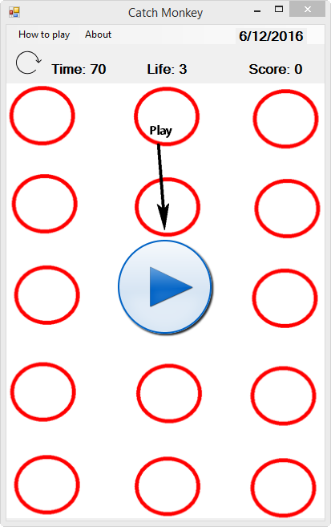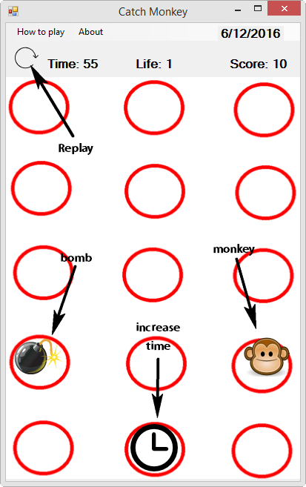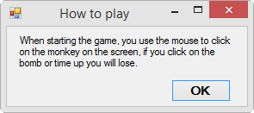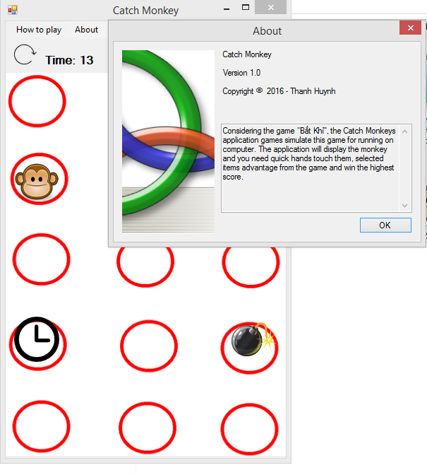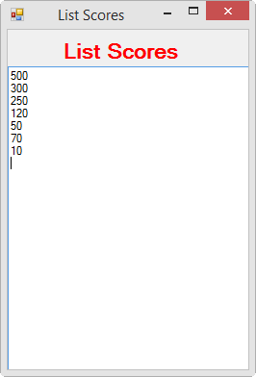

Thank you for watched.

Wish you had a fun time party game.

**Thành Huỳnh**

**Student code: T145588**

**I’m student at VanLang University**